Kindergarten Curriculum
-Numbers to 10
-Two-Dimensional and Three-Dimensional Shapes
-Comparison of Length, Weight, Capacity and Numbers to 10
-Number Pairs, Addition and Subtraction to 10
-Numbers 10-20 and counting to 100
-Analyzing, Comparing, and Composing Shapes
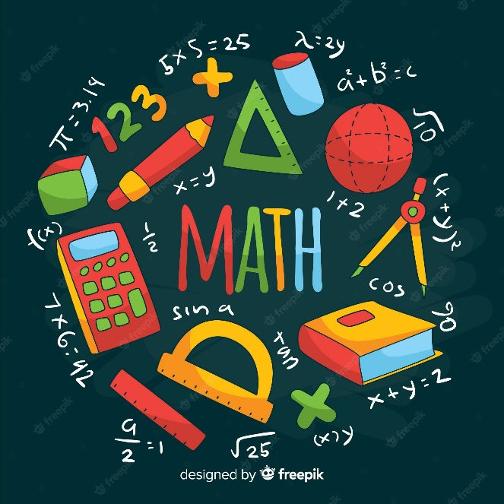
1st Grade Curriculum
-Sums and Differences to 10
-Introduction to Place Value Through Addition and Subtraction within 20
-Ordering and Comparing Length Measurements a Numbers
-Place Value, Comparison, Addition and Subtraction to 40
-Identifying, Composing, and Partitioning Shapes
-Place Value, Comparison, Addition and Subtraction to 100

2nd Grade Curriculum
-Sums and Differences to 100
-Addition and Subtraction of Length Units
-Place Value, Counting, and Comparison of Numbers to 1000
-Addition and Subtraction within 200 with word problems
-Addition and Subtraction within 1000 with word problems
-Foundations of Multiplication and Division
-Problem Solving with Length, Money, and Data
-Time, Shapes, and Fractions as Equal Parts of Shapes

3rd Grade Curriculum
-Properties of Multiplication and Division
-Place Value and Problem Solving with Units Of Measure
-Multiplication and Division
-Multiplication and Area
-Fractions as Numbers on the Number Line
-Collecting and Displaying Data
-Geometry and Measurement Word Problems

4th Grade Curriculum
-Place Value, Rounding, and Multi-digit Addition and Subtraction
-Unit Conversions (measurements)
-Multi-digit multiplication and Division
-Angle Measure and Plane Figures
-Fraction Equivalence, Ordering and Operations
-Decimal Fractions
-Exploring Multiplication

