Grades K-2
Life Unit
Animals
Living/Non-Living
Plants
Senses
Earth & Space Unit
Earth, Moon, and Sun
Weather
Earth's Surface
Physical
Doing Work
Energy
Light
Properties
Magnets
Things Move

Grades 3-4
Life Unit
Vertebrates
Invertebrates
Plant Life
The Human Body
Life Cycles
Habitats/Environment
Earth & Space Unit
The Solar System
Clouds, Wind, & Storm
Minerals, Rocks, and Soil
Physical
Machines
Heat Energy
Sound
Solids, Liquids, and Gases
Process
Thermometers
Balance Scales
Length Measurement
Hard Lenses
Hypotheses
Data Sheets
Using Diagrams
Draw Conclusion
Observation vs. Inference
Identify and Control
Using Graphs
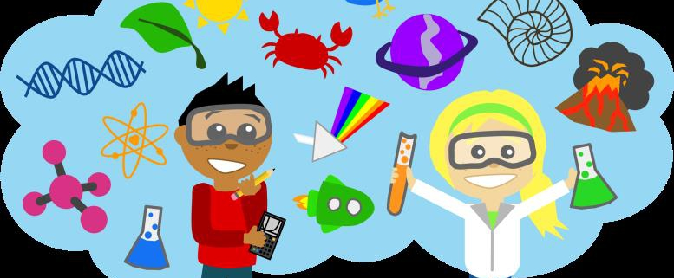

Grades 5-6
Life Unit
Food Chains
Adaptations
Food & Nutrition
Inside Living Things
Earth & Space Unit
Outside the Solar System
Atmosphere and Climate
Changing Landforms
Water
Physical
Force & Motion
Energy Resource
Light Energy
Mixing Matter
Electricity & Magnetism
Process
Thermometers
Balance Scales
Length Measurement
Hard Lenses
Hypotheses
Data Sheets
Using Diagrams
Draw Conclusion
Observation vs. Inference
Identify and Control
Using Graphs

